FITNESS FOR TRANSFER SCREENING

FOR UNACCOMPANIED ASYLUM SEEKING YOUNG PERSON

DATE OF SCREENING: VENUE:

FAMILY NAME:

IN FIRST NAME / NAME KNOWN AS:

INTERPRETER PRESENT? LANGUAGE :

NHS No: GP:

Date of birth: Age: Male/Female

Country of origin: Ethnic Origin: (own description)

Religion: Date of arrival in UK:

Name t CONSENT for fitness for transfer screening:

NAME of interpreter / Contact agency:

NAME of Doctor / Nurse carrying out screening:

PERMISSION for report copies to Designated Professional in new area / GP / Social worker
(delete not applicable)

CURRENT MEDICATION:

ALLERGIES:

ANY HEALTH CONCERNS?

ANY KNOWN HEALTH CONDITIONS?

Have reception staff/foster carer reported any concerns?

PHYSICAL SCREENING
Weight: Kg ( centile) Height: cm ( centile)
Blood pressure: Heart Rate: Respiratory rate:

Temperature: Urine dip:
General appearance:

Any injuries?

Any obvious physical findings?

ANY CONCERNS ABOUT EMOTIONAL/MENTAL HEALTH?

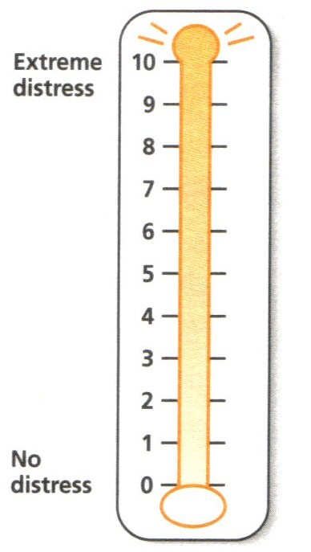


UASC distress screening
Please circle the number (0–10)
that best describes how much
distress you have been experiencing
in the past week including today
Problem list:
Indicate if any of the following have been a problem to you in the past week.
Family:
Bereavement
Loss of contact with family
Concern about family safety

Emotional: Spiritual:
Fear Loss of hope
Anxiety Loss of spiritual
Nightmares practices
Hypervigilance Loss of spiritual
community
Physical: Unhappy with
Fatigue how living life
Constipation Loss of peace
Sleep
Indigestion

UASC distress screening

Solution Focused Care Plan:

0 – 5: UASC does not require additional EM&WB support. Watch, wait and see protocol to be maintained. Level 2 clinician required from a competencies perspective.

6 – 7: UASC requires additional EH&WB support based on the Early Intervention
Framework and a level 3 clinician is required from a competencies perspective.

8 – 10: UASC requires additional EH&WB support and review based on the Early Intervention Framework and input from a level 4 clinician required from a competencies perspective.

Solution process:

Is sleep work required and been undertaken? Yes No

Is re-feeding work required and been undertaken? Yes No

Is hope work required and been undertaken? Yes No

IMMUNISATION STATUS ON ARRIVAL:

Unknown Missing Information Complete

IMMUNISATIONS GIVEN:

OPINION

DISPERSAL SHOULD BE DELAYED
Reasons:

Action Required:

Plan:

Who has been informed:

CHILD/YOUNG PERSON CAN MOVE BUT THERE ARE “SPECIAL CIRCUMSTANCES”

Reason:

Action required:

Plan:

CHILD/YOUNG PERSON CAN MOVE

RECOMMENDATION:
This young person will require a Statutory Initial Health Assessment to be arranged on arrival in Receiving Local Authority.

OTHER:

Copies: Young Person (for their health passport), Social Worker, File

The following is guidance used at the IHA stage in Kent:

- The majority of children & young people will not have complete immunisation records so will need to start the current UK schedule
- TB screening is required for all children & young people irrespective of presence of BCG scar.
- Given the risks it has been recommended that all children & young people are screened for Hepatitis B & C, HIV & syphilis
- High numbers of UASCs have dental concerns and will need to access dental services.
- High numbers of UASCs have vision problems and will need access to opticians.
- High numbers of UASCs have experienced gastro intestinal symptoms on arrival in the UK, possibly due to re-feeding and would benefit from nutrition advice.
- High numbers of UASCs have presented with sleep onset difficulties and would benefit from sleep hygiene.
- There are increased safeguarding risks in this group of children and young people.

Kent CCGs have developed a number of resources to assist and these are available at our UASC health website.

Signature:

Title:

Date:

